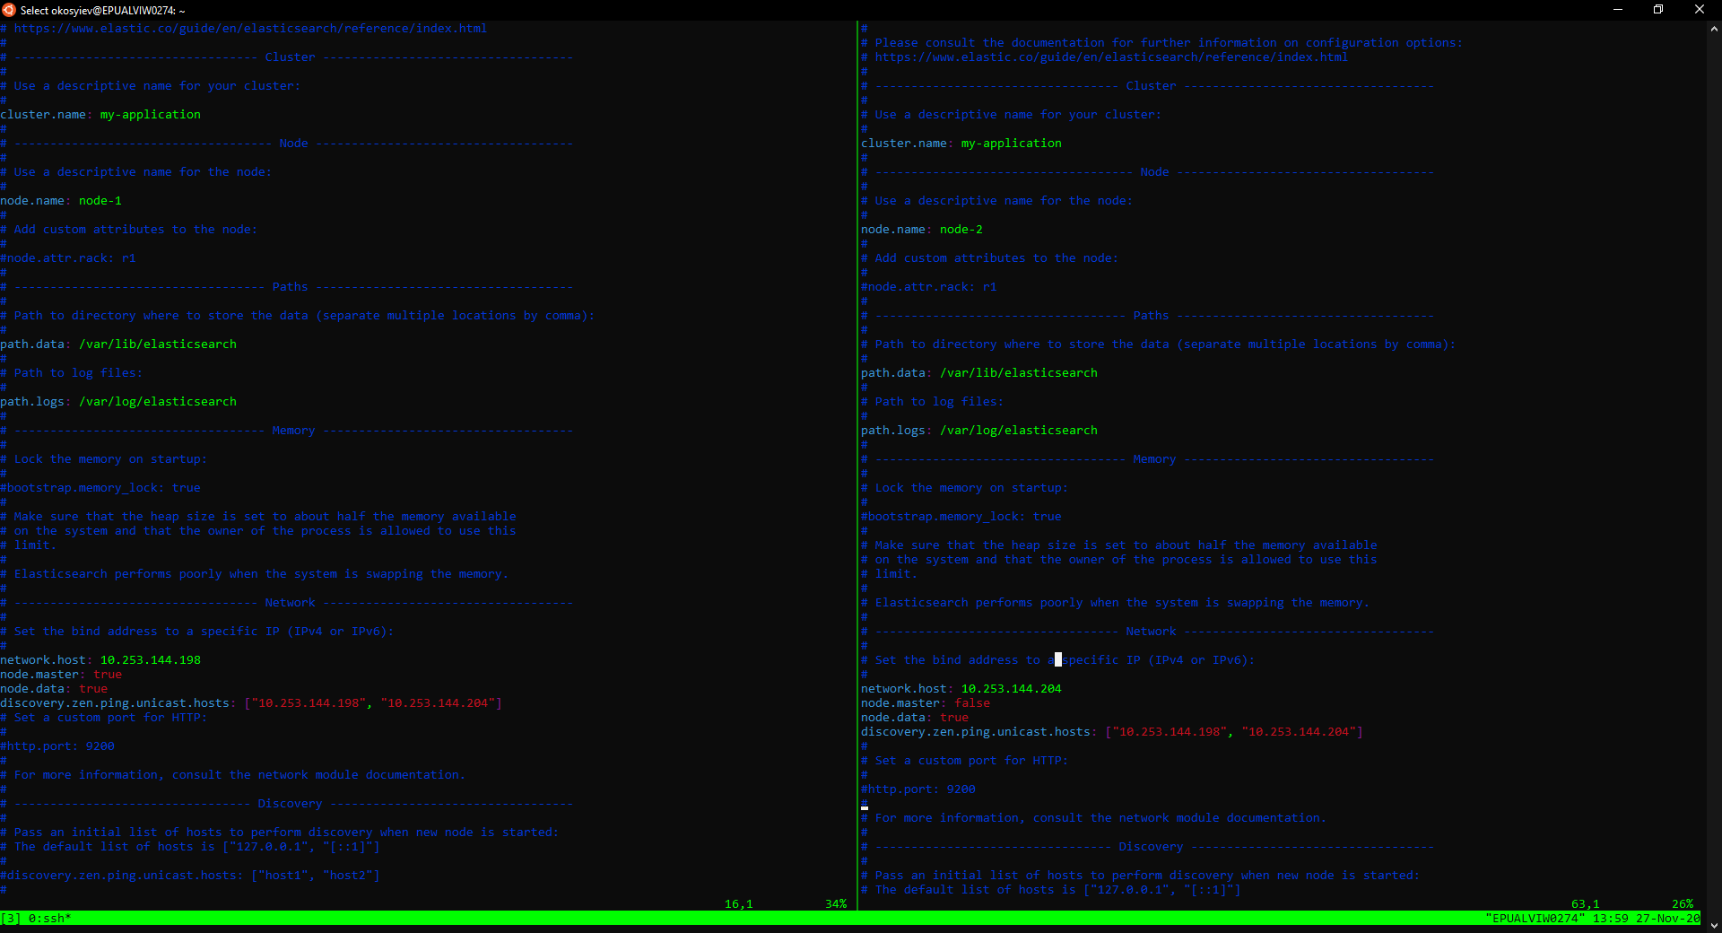

echo "deb https://artifacts.elastic.co/packages/7.x/apt stable main" | sudo tee /etc/apt/sources.list.d/elastic-7.x.list

wget -qO - https://artifacts.elastic.co/GPG-KEY-elasticsearch | sudo apt-key add -

sudo apt update

sudo apt-get install openjdk-11-jdk -y

sudo apt install -y elasticsearch

sudo /bin/systemctl daemon-reload

sudo /bin/systemctl enable elasticsearch.service

sudo systemctl start elasticsearch.service

sudo systemctl status elasticsearch.service

###--- check conection

curl -u elastic:elasticsearch -XGET http://10.253.145.133:9200/_cluster/health?pretty

#### --- install password

cd /usr/share/elasticsearch/

sudo bin/elasticsearch-setup-passwords interactive

### install snapshot repo

sudo /usr/share/elasticsearch/bin/elasticsearch-plugin install repository-azure

sudo /usr/share/elasticsearch/bin/elasticsearch-keystore add azure.client.default.account

sudo /usr/share/elasticsearch/bin/elasticsearch-keystore add azure.client.default.key

systemctl restart elasticsearch.service

curl -XPUT http://10.253.145.133:9200/_snapshot/uat-cdpuk-repository -H 'Content-Type: application/json' -d '{"type": "azure",

"settings": {

"location": "https://saeuuksuatcdpuksnap01.blob.core.windows.net",

"container": "uat-cdpuk-repository",

"base_path": "/"

}}'

#### index template

curl -XPUT -H 'Content-Type: application/json' http://10.253.144.198:9200/_template/transaction-log-template -d @transaction-log-template.json

#sudo vim /etc/elasticsearch/elasticsearch.yml

master

cluster.name: my-application node.name: node-1 path.data: /var/lib/elasticsearch

path.logs: /var/log/elasticsearch

repositories.url.allowed_urls: ["https://saeuuksuatcdpuksnap01.blob.core.windows.net/uat-cdpuk-repository"]

network.host: 10.253.144.198 node.master: true node.data: true discovery.seed_hosts: ["10.253.144.198", "10.253.144.204"]

cluster.initial_master_nodes: ["10.253.144.198"]

nodes

cluster.name: cdpuk node.name: node-2 path.data: /var/lib/elasticsearch path.logs: /var/log/elasticsearch

repositories.url.allowed_urls: ["https://saeuuksdevcdpuksnap01.blob.core.windows.net/dev-cdpuk-repository"] network.host: 10.253.144.204 node.master: false

node.data: true discovery.seed_hosts: ["10.253.144.198", "10.253.144.204"]

cluster.initial_master_nodes: ["10.253.144.198"]

<https://www.youtube.com/watch?v=i4T1PNQZsiY>

installing security